LIGTAS SAKAY MOBILE APPLICATION

Project Documentation Submitted

To the Faculty of School of

Computer Science and Information Technology

Of

Asia Pacific College

In Partial Fulfillment of the Requirements for the Subject

SYSADD1

By

Dizon, Dan Patrick R.

Maraya, Lorina P.

Pilares, Dwight Stephen Paolo C.

Pintado, Vic Arthur G.

To promote

Ligtas Patrol Group

Table of Contents:

2.[- Professor](http://projects2.apc.edu.ph/wiki/index.php/Project_-_Ligtas_Sakay_Mobile_Application#Professor)

3.[- Adviser/Project Consultant](http://projects2.apc.edu.ph/wiki/index.php/Project_-_Ligtas_Sakay_Mobile_Application#Adviser.2FProject_Consultant)

4.[- Project Team](http://projects2.apc.edu.ph/wiki/index.php/Project_-_Ligtas_Sakay_Mobile_Application#Project_Team)

5.[- General Objectives](http://projects2.apc.edu.ph/wiki/index.php/Project_-_Ligtas_Sakay_Mobile_Application#General_Objectives)

6.[- Specific Objectives](http://projects2.apc.edu.ph/wiki/index.php/Project_-_Ligtas_Sakay_Mobile_Application#Specific_Objectives)

7.[- Target Audience](http://projects2.apc.edu.ph/wiki/index.php/Project_-_Ligtas_Sakay_Mobile_Application#Target_Audience)

8.[- Project Description](http://projects2.apc.edu.ph/wiki/index.php/Project_-_Ligtas_Sakay_Mobile_Application#Project_Description)

9.[- Glossary](http://projects2.apc.edu.ph/wiki/index.php/Project_-_Ligtas_Sakay_Mobile_Application#Glossary)

- SYSADD1 (Proposed)

10-.[-Event Table](http://projects2.apc.edu.ph/wiki/index.php/Project_-_Ligtas_Sakay_Mobile_Application#Event_Table)

11.[-Use Case Diagram](http://projects2.apc.edu.ph/wiki/index.php/Project_-_Ligtas_Sakay_Mobile_Application#Use_Case_Diagram)

12.[-Use Case Full Description](http://projects2.apc.edu.ph/wiki/index.php/Project_-_Ligtas_Sakay_Mobile_Application#Use_Case_Full_Description)

13.[-Context Flow Diagrams](http://projects2.apc.edu.ph/wiki/index.php/Project_-_Ligtas_Sakay_Mobile_Application#Context_Flow_Diagrams)

14.[-Data Flow Diagrams](http://projects2.apc.edu.ph/wiki/index.php/Project_-_Ligtas_Sakay_Mobile_Application#Data_Flow_Diagrams)

15.[-Entity Relationship Diagrams](http://projects2.apc.edu.ph/wiki/index.php/Project_-_Ligtas_Sakay_Mobile_Application#Entity_Relationship_Diagrams)

16.-Sequence Diagram

17.-Class Diagram

18.-Object Diagram

19.-Component Diagram

20.-Composite Diagram

21.-Interaction Diagram

22.-Package Diagram

23.-State Machine Diagram

24.-Timing Diagram

25.[-Activity Diagram](http://projects2.apc.edu.ph/wiki/index.php/Project_-_Ligtas_Sakay_Mobile_Application#Activity_Diagram)

26.[-Data Dictionary](http://projects2.apc.edu.ph/wiki/index.php/Project_-_Ligtas_Sakay_Mobile_Application#Data_Dictionary)

27.[-Gantt Chart/WBS/Activity List](http://projects2.apc.edu.ph/wiki/index.php/Project_-_Ligtas_Sakay_Mobile_Application#Gantt_Chart.2FWBS.2FActivity_List)

1. Professor – Mr. Manuel Sanchez
2. Adviser – Mr. Ernesto Boydon
3. Project Team – Dwight Stephen Paolo C. Pilares

Dan Patrick R. Dizon

Lorina P. Maraya

Vic Arthur G. Pintado

1. General Objectives:

To Develop a system for the general welfare and protection of public and private transportation commuters.

1. Specific Objectives:

* To enable passengers to report abusive PUV Drivers
* To enable passengers to report violations they have encountered
* To let commuters experience a safer and more efficient travel experience

1. Target Audience:

* Public and Private Transportation commuters

1. Project Description:

* Ligtas Sakay Mobile Application is a safety commuting application which can help passengers immediately report abusive PUV Drivers they may encounter. Summary features of the application includes QR Code Scanner - Scan QR Code of PUV and automatically shows information of the vehicle, as well as driver's personal information and send it to assigned contact, Track users' location, Report Button and Danger Button.

1. Definition of Key Terms

* Mobile Application - a type of software designed to run on a mobile device.
* Commuters - a person who travels some distance from residence to work on a regular basis.
* System Admin - a person who is responsible of the System Operation
* PUV - Public Utility Vehicle

10). Event Table:

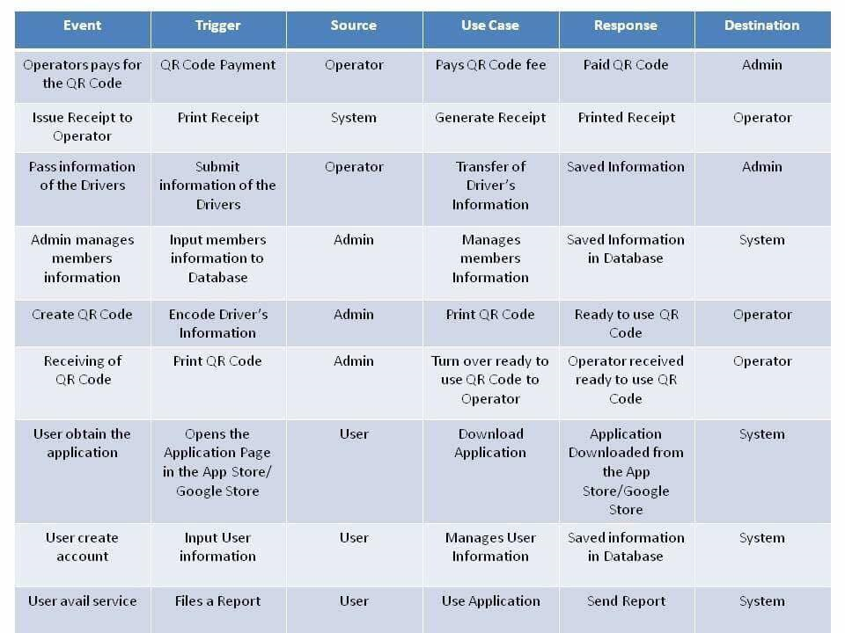

11). Use Case Diagram:

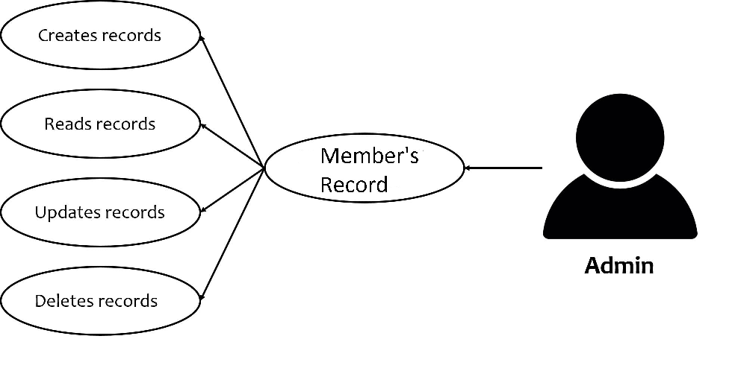

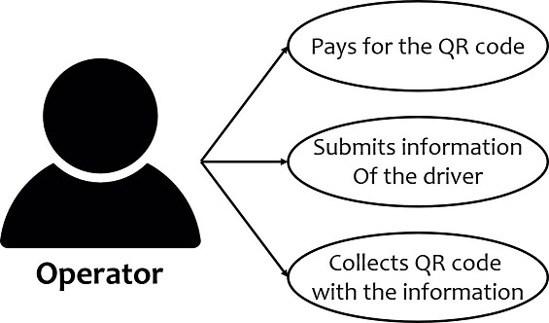

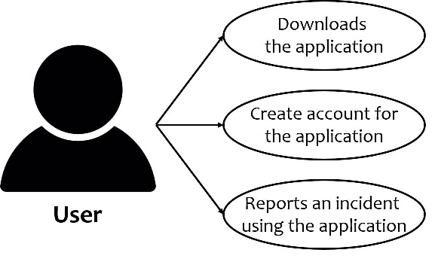

12). Use Case Full Description

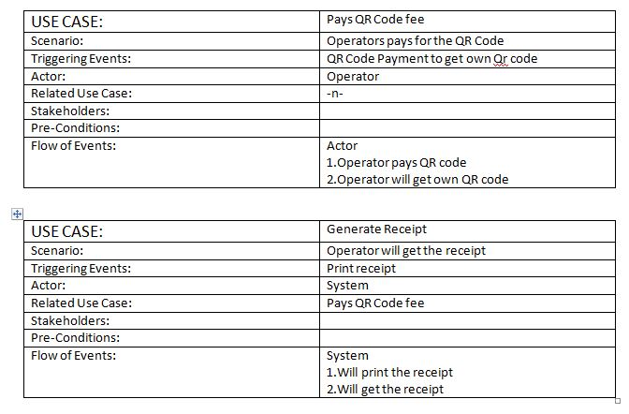

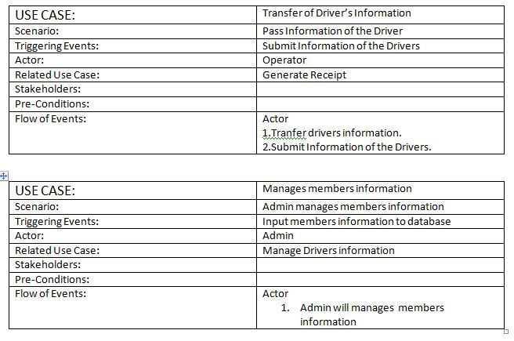

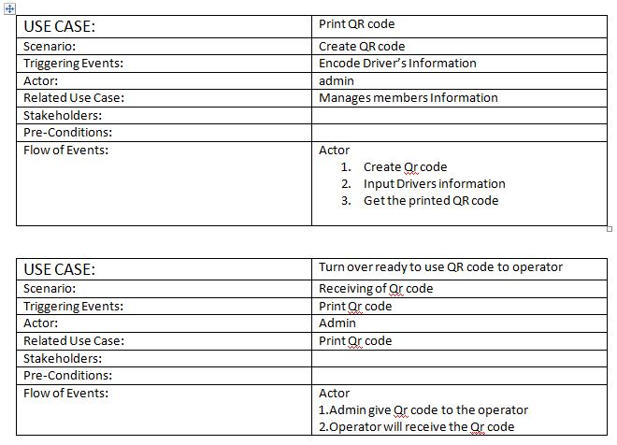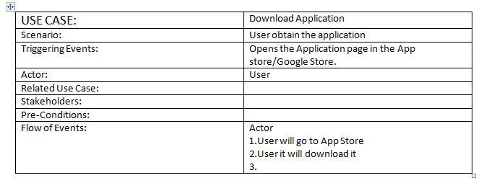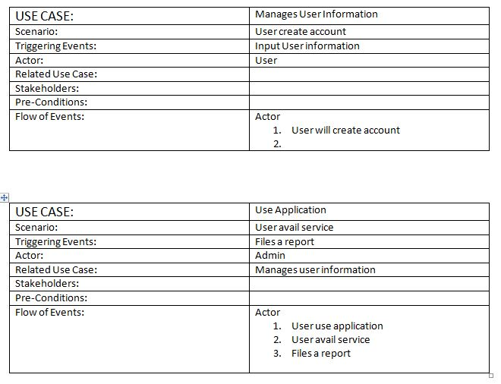

13). Context Flow Diagram:

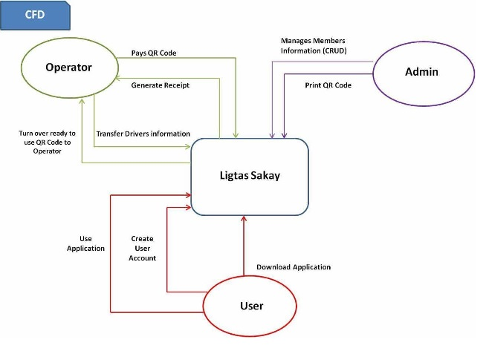

14). Data Flow Diagram:

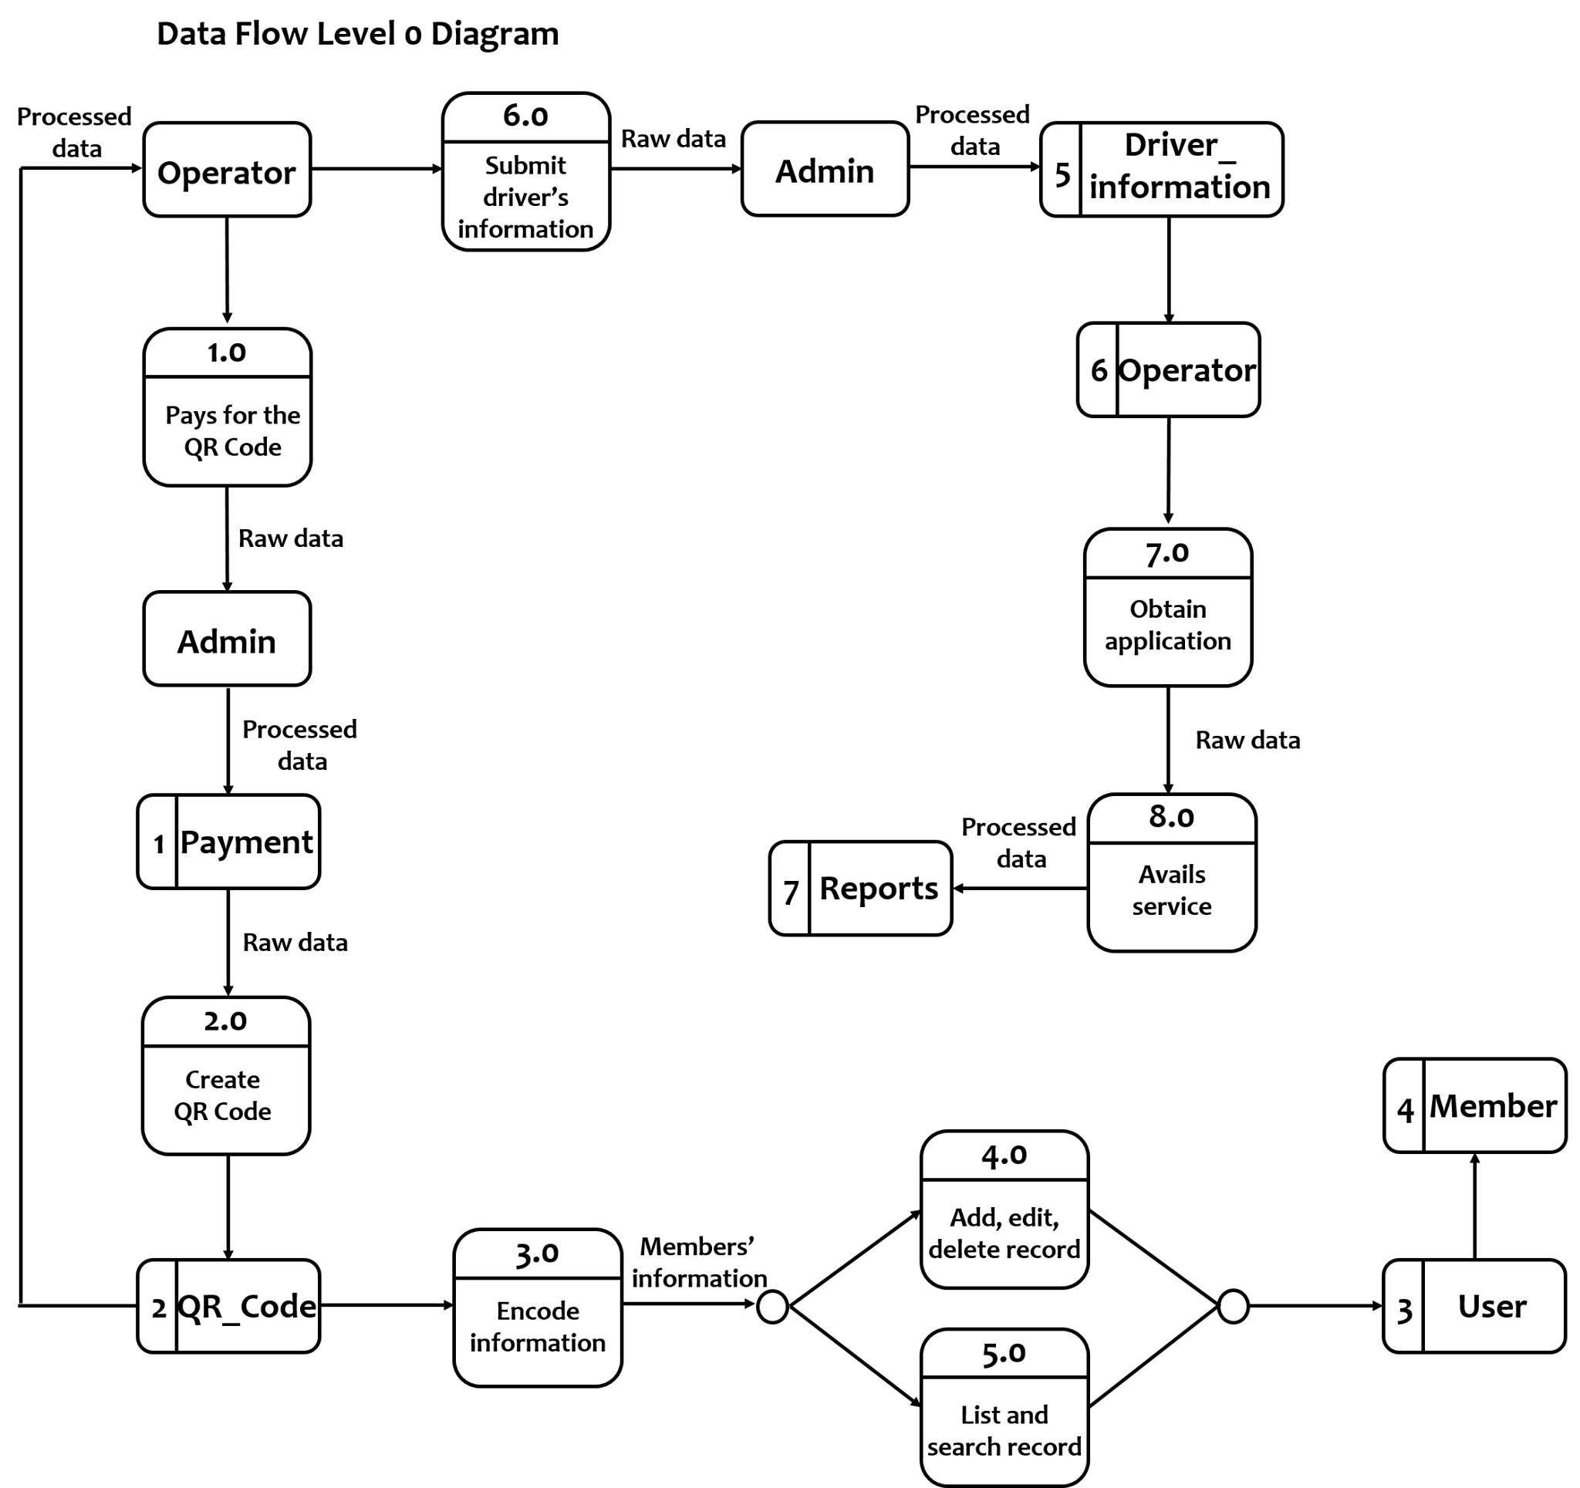

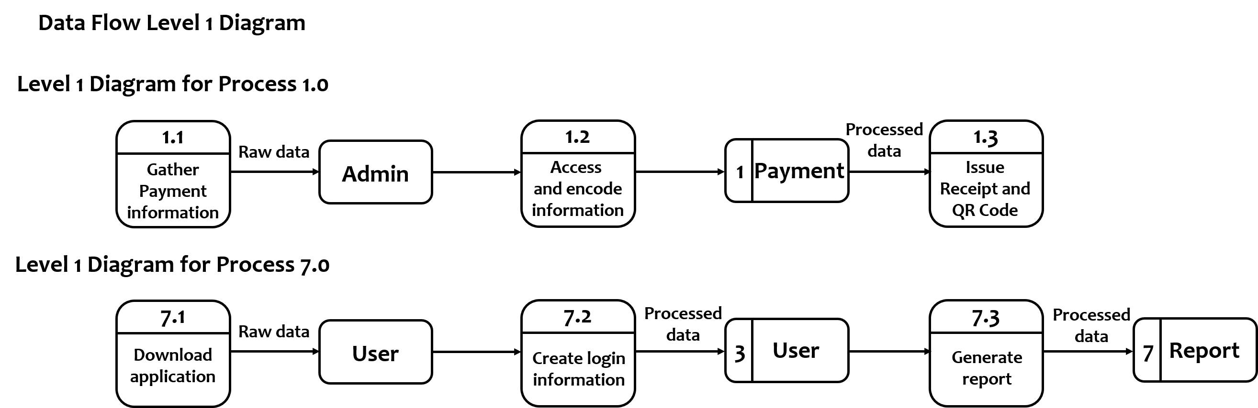

14). Sequence Diagram:

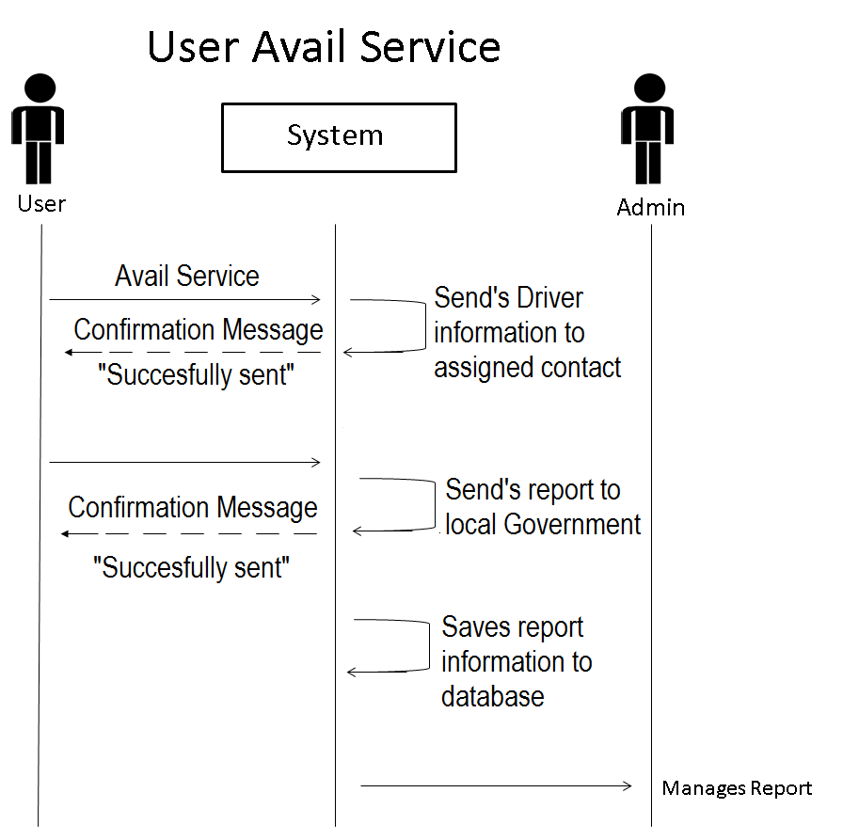

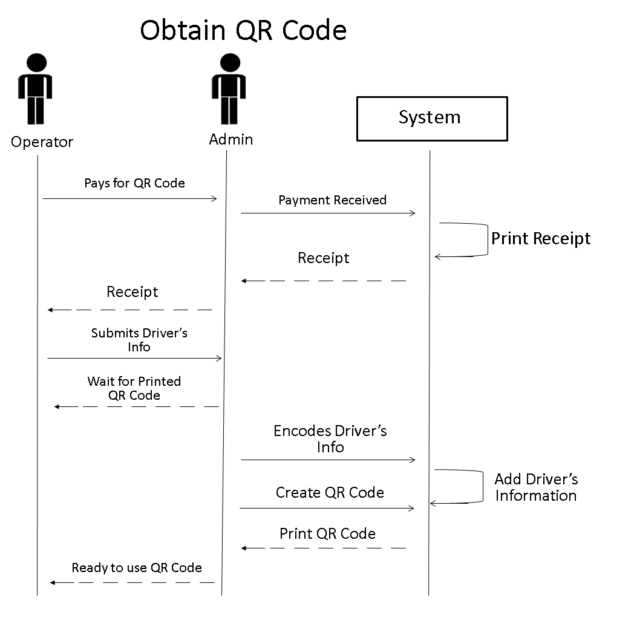

15). Class Diagram:

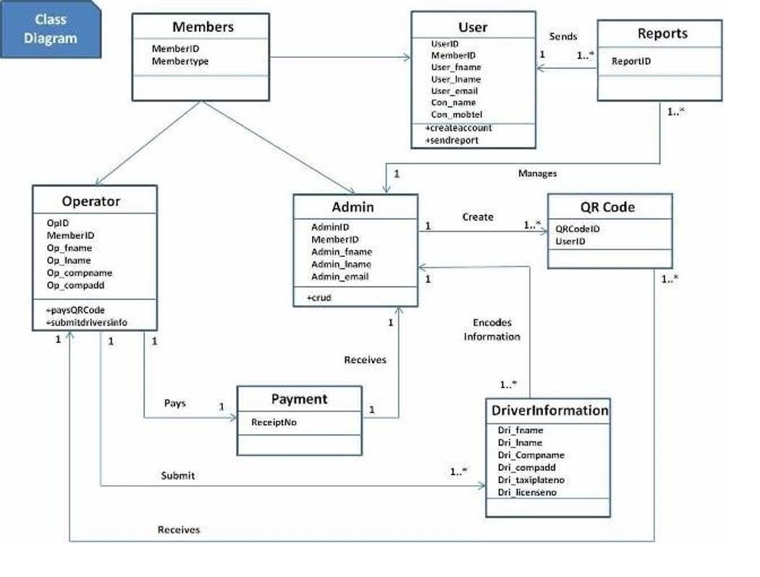

16). Object Diagram

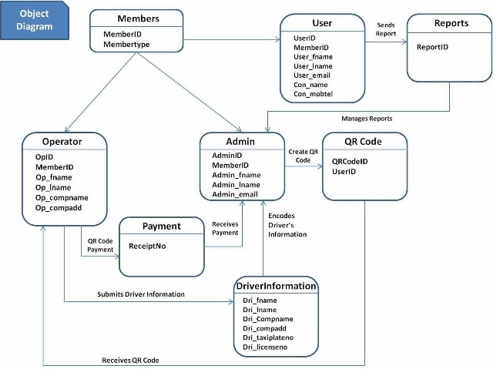

17). Component Diagram

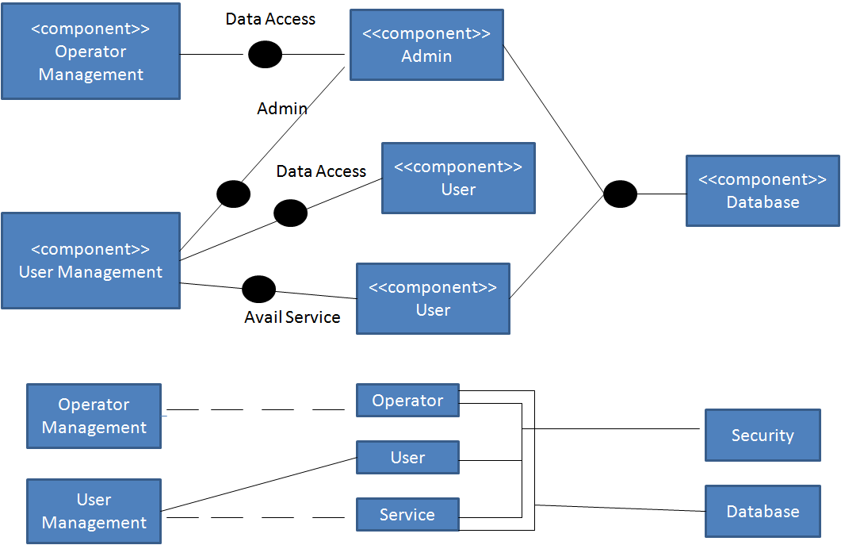

18). Composite Diagram:

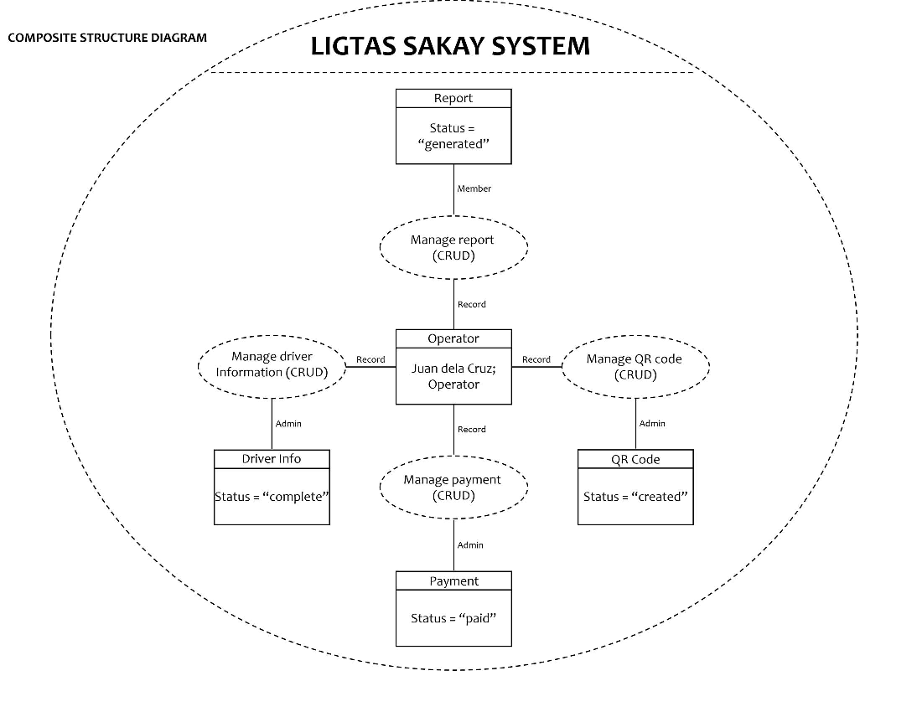

19). Interaction Diagram:

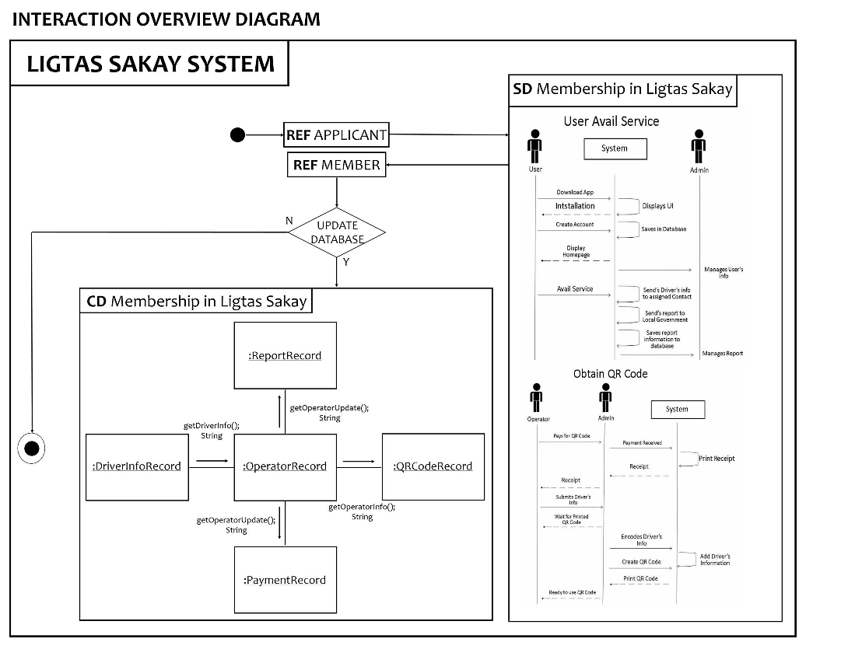

20). Package Diagram:

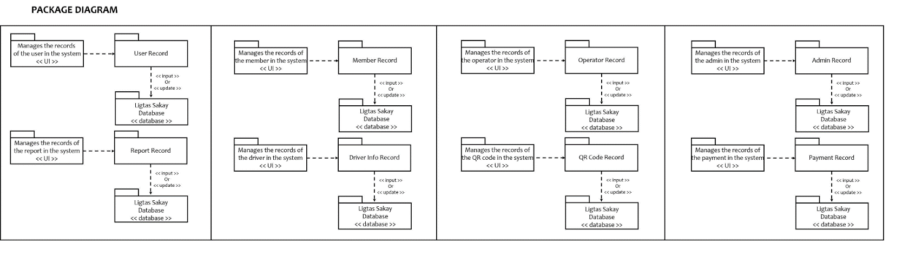

21). State Machine Diagram:

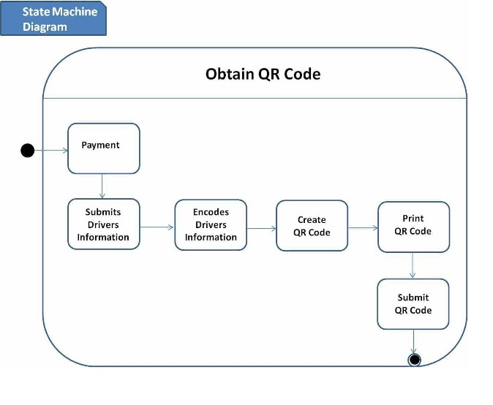

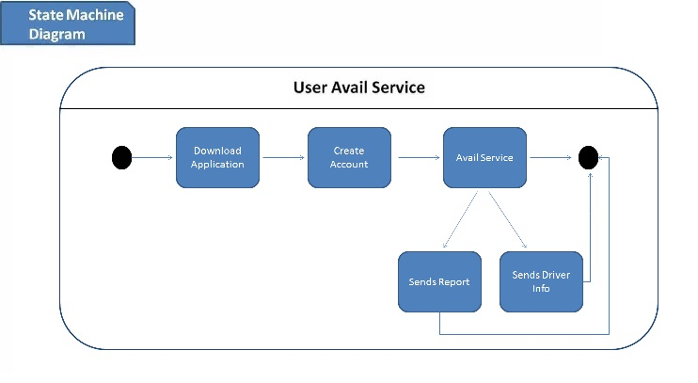

22). Timing Diagram:

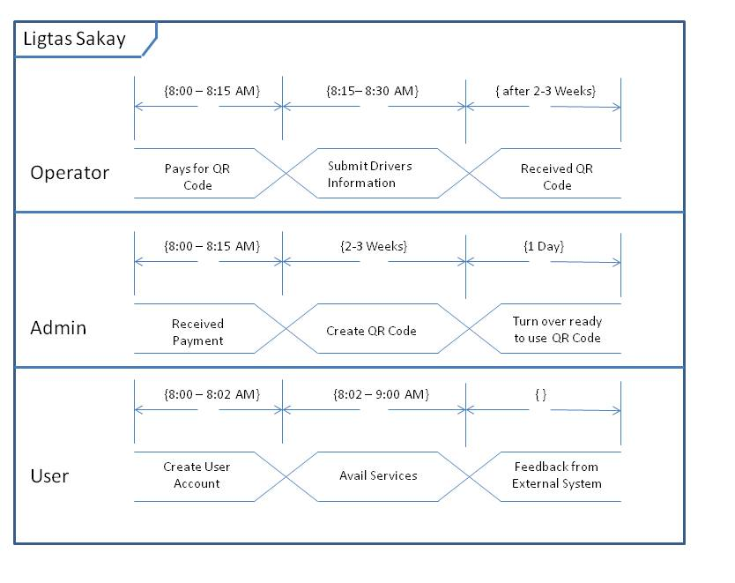

23). Entity Relationship Diagram:

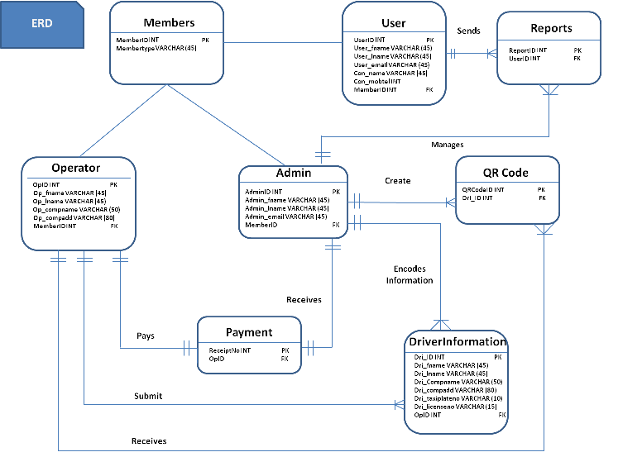

24). Activity Diagram:

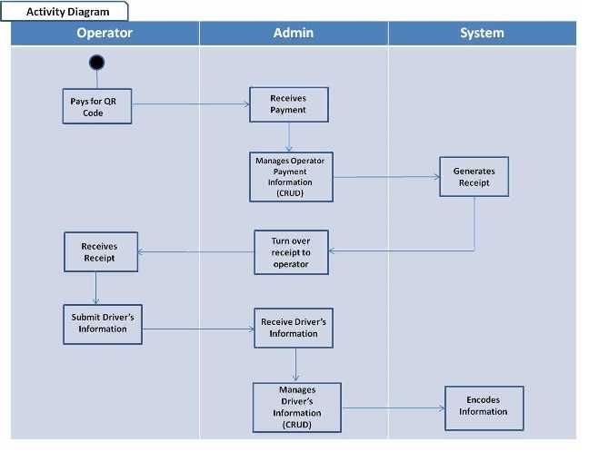

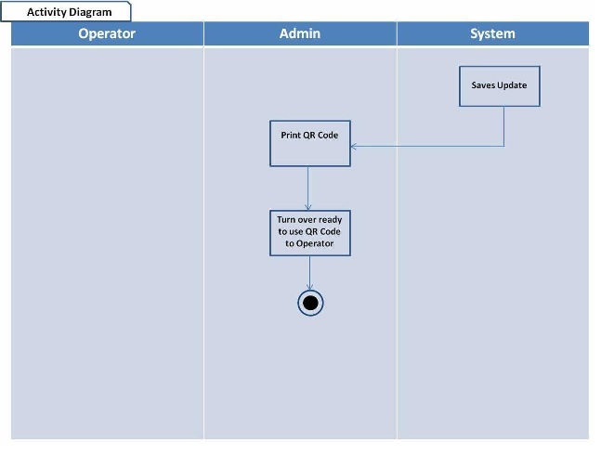

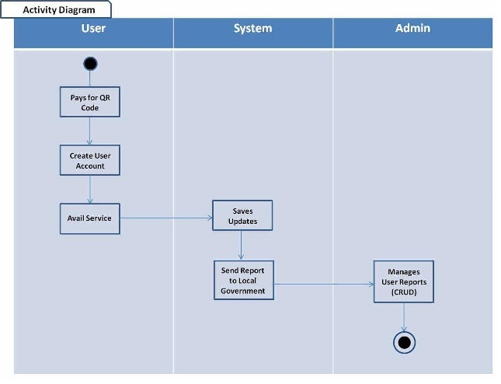

25). Data Dictionary:

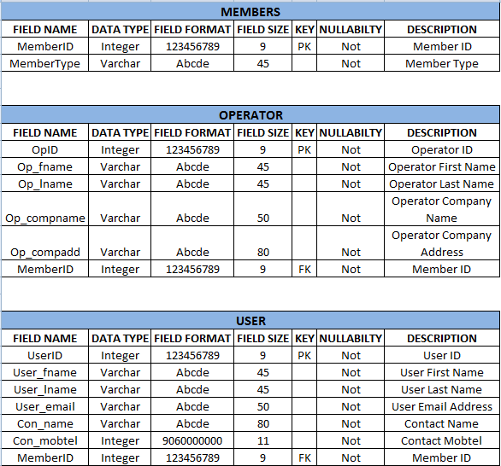

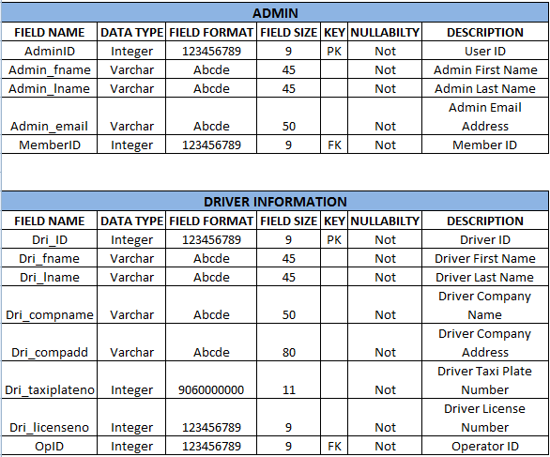

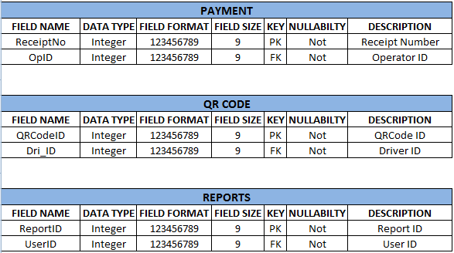

26). Gantt Chart/WBS/Activity List

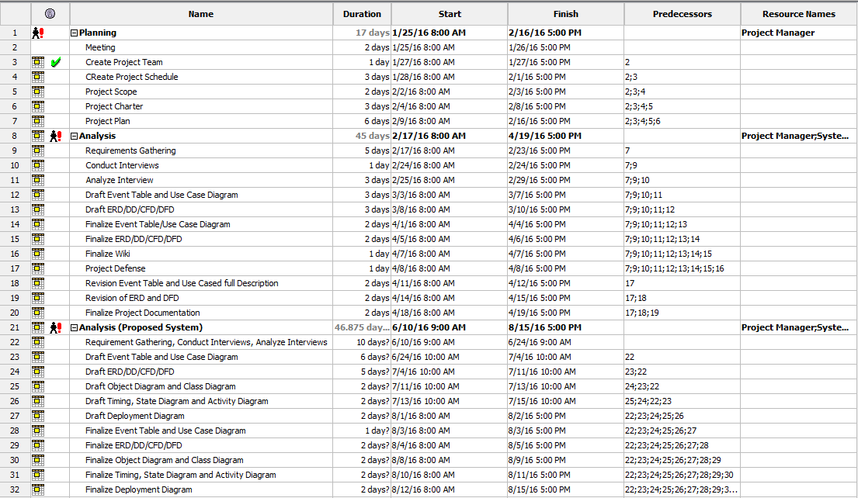

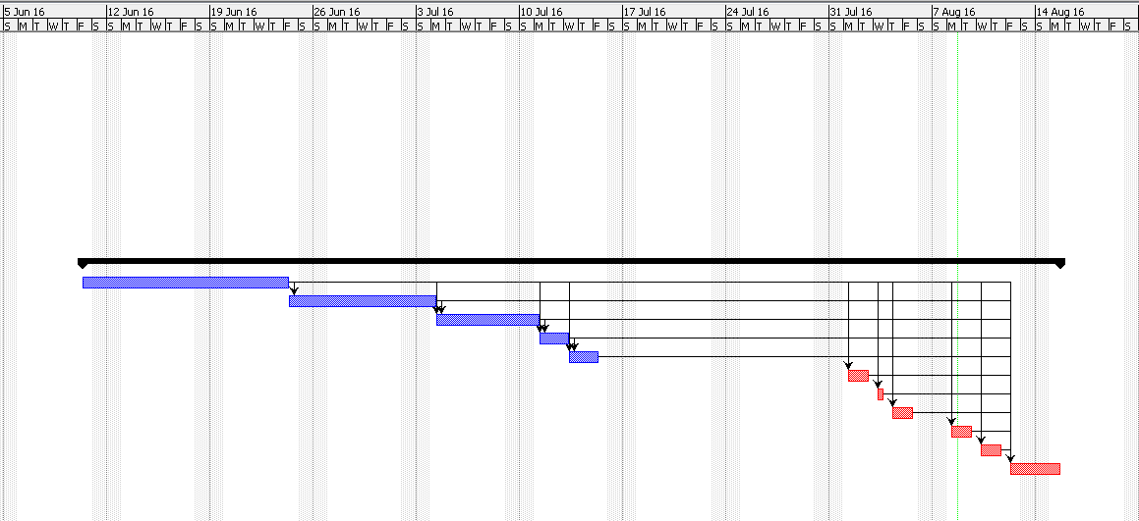

27). WBS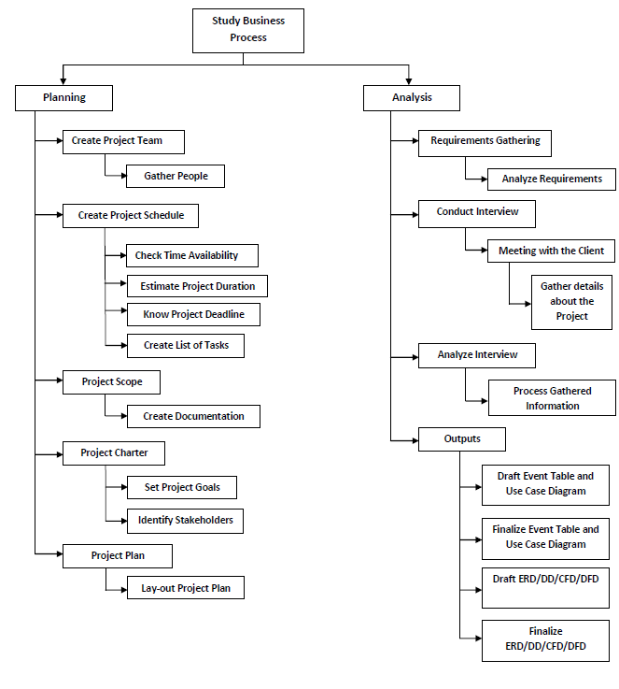

28). Activity List:

